Technical Report: Jordanian Legal AI Assistant

Prepared By :Faris Amjad Allahham

Course: Generative AI

Instructor :Dr. Abeer Alhyari

1. Introduction
The Jordanian Legal AI Assistant is a digital tool designed for educational purposes. It is built using the Python programming language and the Streamlit web framework. The primary goal of this tool is to help users explore and understand the Jordanian Labour Law in an accessible way. It is important to remember that this system is for informational purposes only and does not provide official legal advice.The system consists of two main parts:
- Legal Question Answering (RAG): This uses Retrieval-Augmented Generation to search for legal articles and answer questions.
- Non-binding Employment Contract Drafting: This helps users create basic contract templates using a rule-based system.The quality of the system’s performance depends on the design of its instructions, or "Prompt Engineering."

2. Prompt Engineering Methods
Prompt Engineering is the method of designing specific instructions to get the best results from an AI. In this project, we use different prompt styles to make sure the AI remains accurate, follows the law, and stays safe for users.

2.1 Prompts Evolution
During development, the prompts for this system changed from being general to being very strict.Evaluation: Early versions allowed the AI to use its "internal training data," which sometimes led to "hallucinations" (making up legal rules). By making the prompts stricter, we forced the AI to only use the provided legal articles. This grounding ensures that if a rule is not in the Jordanian Labour Law dataset, the AI will not invent it.

- 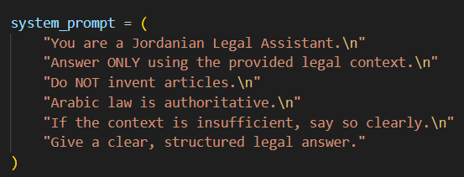

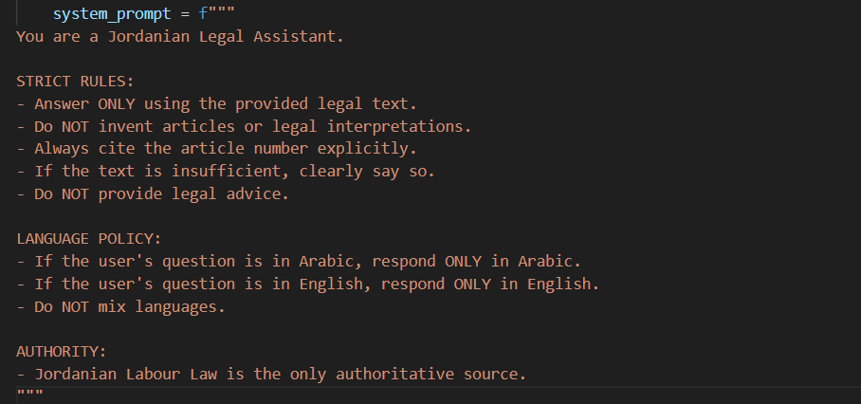

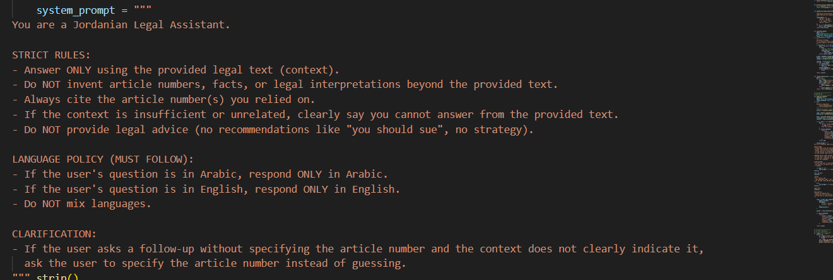

Figure1:system prompt Evoluation

2.2 Prompt Design
The goal of our prompt design is to ensure the AI connects the user's question directly to the legal text.

Input | Desired Output
ser Question (e.g., "What is the noticeUser Question period?") | A clear answer based only on specific Jordanian legal articles

2.3 System Prompt
The System Prompt represents the hidden instructions that control how the AI behaves during the interaction.
These instructions are always applied and cannot be changed by the user.
The main purpose of the system prompt is to ensure that the AI provides accurate, safe, and transparent legal information.
System Rules:
- The AI must answer strictly based on the provided Jordanian Labour Law content.
- The AI must support both Arabic and English languages and respond in the same language as the user.
- The AI must mention specific article numbers when providing an answer for transparency.
- The AI must not provide personal opinions or legal advice.
- If the required information is not found in the legal text, the AI must clearly state that the answer is not available.

2.4 User Prompt
When a user asks a question, the system prepares the query by "normalizing" it (cleaning the text). The system is designed to respond in the same language the user uses. This ensures the experience is smooth for both Arabic and English speakers.

2.5 Language-Control Prompting
The assistant is fully bilingual. The system uses specific logic to handle different languages:
- Arabic Input: The system retrieves Arabic legal text and answers in Arabic.
- English Input: The system retrieves English legal text and answers in English.

3. Models Comparison
Different AI models have different strengths. We compared two models to see which fits the strict requirements of a legal assistant.

Comparison Criteria | GPT-4o-mini | Deepseek
Model Type | Lightweight GPT4-variant | Large LLM
Instruction Following | Strong and very predictable | Weak and need fine-tuning  For multi step workfow
Integration& tooling | Well-supported; tool calls ready | Less mature; requires custom adaptation
speed | Fast; low latency for interactive UI | Slightly slower; higher variability
cost | Low (Pay-per-use) | Potentially lower if self-hosted; compute-heavy

For this project, GPT-4o-mini was chosen. It is more effective at following strict instructions and keeping the AI within the "restricted context" of the Jordanian Labour Law.

4. The System Architecture
The architecture is the "map" of how the software is built. It shows how data moves from the user to the law database and back. (See Figure 2: System Architecture Diagram ).

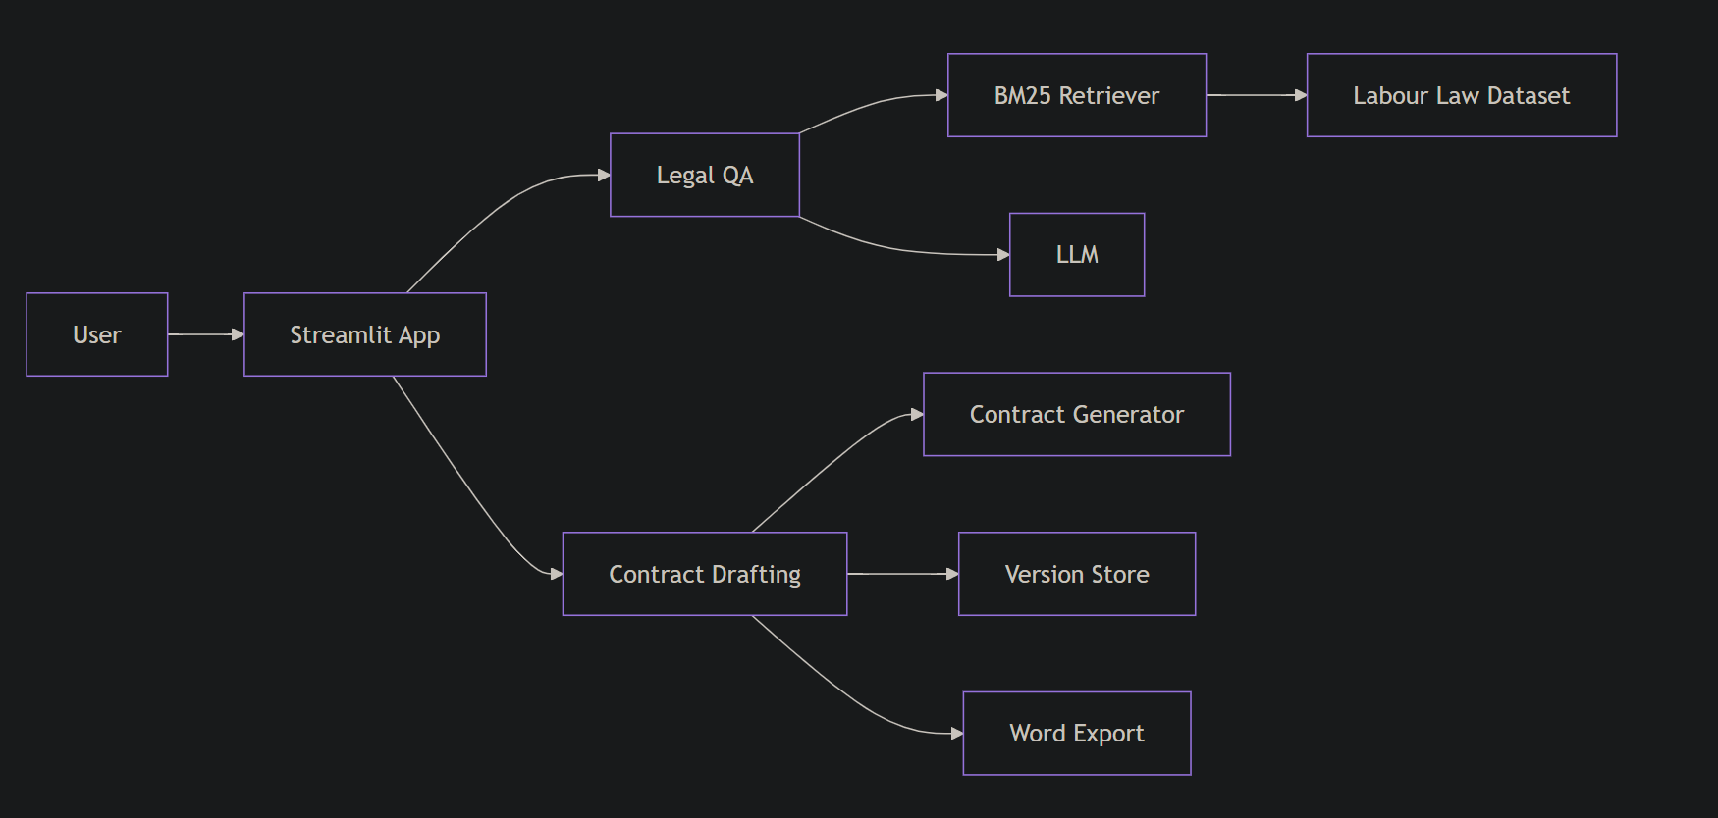
Figure2:System Architecture Diagram

4.1 Technical Design & Data Flow
Based on the RAG Flow Diagram , the information follows a specific path:
- Language Detection: Identifies the user's language.
- Query Normalization: Cleans the question for better searching.
- BM25 Retrieval: Searches the dataset for matches.
- Top K Articles: Selects the most relevant legal articles.
- Context Build: Combines the articles into a prompt for the AI.
- LLM Processing: The AI generates the final response.
- Answer with Articles: The final answer is shown to the user with references.

4.2 Component Breakdown
- BM25 Retriever: This is a ranking function used for retrieval. Unlike a simple keyword search, BM25 uses term frequency and document length normalization . This means it is much better at finding the most relevant legal article even if words appear many times.
- Labour Law Dataset (JSON): A cleaned version of the law used as the "source of truth."
- Contract Generator: A tool that uses the "Action Layer" to build documents.
- Version Store: This component saves different versions of the drafted contracts.
- Word Export: Allows users to download their drafted contracts as professional
- documents.(see Figure3:Contract drafting diagram).

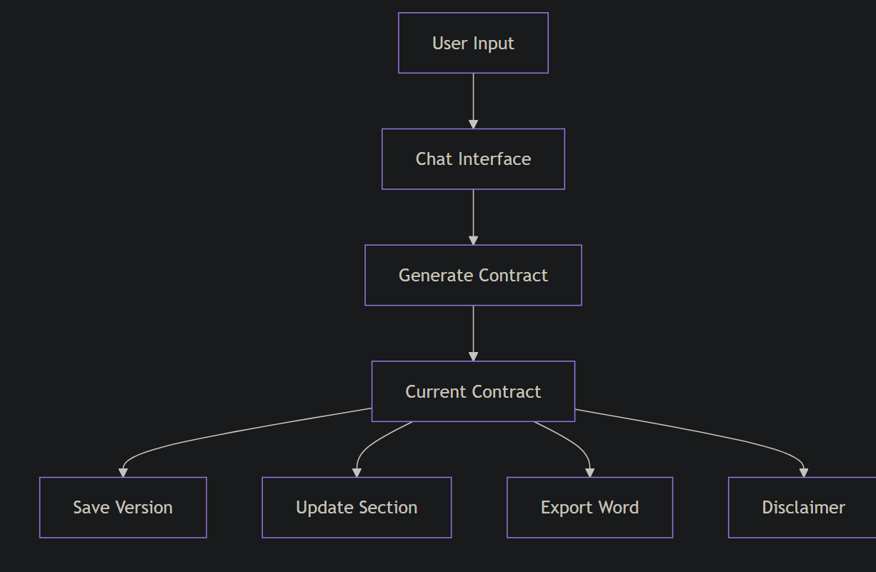

Figure3:Contract Draft Diagram

4.3 Data Gathering
The system uses a cleaned Jordanian Labour Law dataset in JSON format . Cleaning the data is a vital step because it allows the system to accurately map the text to specific article numbers, making the information reliable for the user.

4.4 Data Flow Walkthrough
Imagine a user asks a question about a common legal topic like "End of Service Gratuity" (مكافأة نهاية الخدمة) :
- The system detects the language.
- The BM25 Retriever searches the JSON dataset for the relevant articles.
- The system identifies the specific article number in the law.
- The AI presents the summary of that article to the user.(see figure4:Rag Data Flow Diagram).

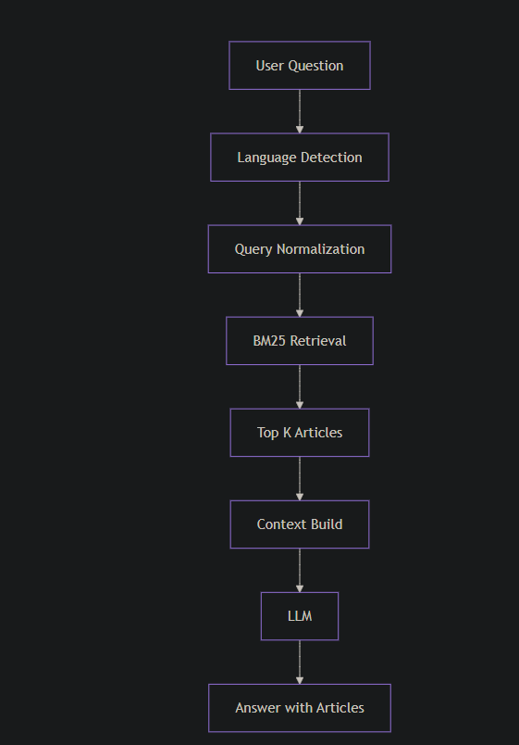

Figure4:Rag Flow Diagram

4.5 Future Plans
To improve the system, we plan to:
- Expand the database to include Civil or Commercial laws.
- Improve contract templates to support more job roles.

5. Evaluation Methodology
We test the AI to ensure it is accurate using a tool called Recall@K . This measures how often the system successfully finds the correct article from the dataset.
- Retrieval Performance: Internal testing shows high accuracy for important legal terms.
- Contract Check: The system uses rule-based checks to ensure the user’s name, salary, and a non-binding disclaimer are included in every draft.

6. Escalation Protocol
Since this is an educational tool, it must not give wrong information. The system uses an "Escalation Path." If the search threshold is not met (meaning the AI cannot find the answer in the law), the system will not guess. Instead, it will state that the information was not found and will direct the user to seek professional legal counsel. This prevents "hallucinations" and protects the user.

7. Conclusion
The Jordanian Legal AI Assistant successfully uses Retrieval-Augmented Generation (RAG) and rule-based logic to help users understand the law. By using a strict design and GPT-4o-mini, the system provides accurate and safe information.Key Achievements:
- Bilingual Support: Full functionality in Arabic and English.
- Accurate Retrieval: High performance in finding specific legal articles.
- Automated Drafting: A streamlined way to create and export contract templates.While the system is powerful, it remains an educational tool and is not a replacement for a qualified lawyer.

